Name_____________________________________Date____________________________
Chapter 1: What is Geography?

True/False
Indicate whether the statement is true or false.

____ 1. The oldest land formation in North America is the Appalachian Mountains.
A. True
B. False

____ 2. The terrain and soil of the Blue Ridge region is well suited for farming.
A. True
B. False

____ 3. The Piedmont Region makes up approximately one-half of the state of South Carolina.
A. True
B. False

____ 4. Greenville is considered the geographic center of the state.
A. True
B. False

____ 5. In 1886 the Charleston earthquake killed 83 people and destroyed one-quarter of the buildings.
A. True
B. False

Multiple Choice
Identify the choice that best completes the statement or answers the question.

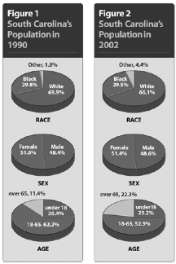

____ 1. According to the two graphs, by what percent have races other than black and white grown from 1990 to 2002?
A. | 1.2 percent
B. | 1.6 percent
C. | 2.3 percent
D. | 2.6 percent

____ 2. According to the two graphs, what area has seen the largest increase between 1990 and 2002?
A. | age: under 18
B. | age: over 65
C. | race: blacks
D. | sex: women

____ 3. From the information on the graphs, which statement BEST describes the change in South Carolina’s population between 1990 and 2002?
A. | The population is declining.
B. | The population is getting older.
C. | The population is getting younger.
D. | The population is becoming less diverse.

____ 4. What type of climate does South Carolina have?
A. | continental
B. | humid continental
C. | tropical
D. | subtropical

____ 5. Which river is a tributary of the Savannah River?
A. | Congaree
B. | Saluda
C. | Tugaloo
D. | Tyger

Completion
Complete each statement.

1. __________________is the precise position by longitude and latitude.

2. Animal life is called ____________________

3. ____________________is approximately the geographic center of the state.

Matching

Match the term with its definition.
A. | climate | I. | latitude
B. | elevation | J. | longitude
C. | environment | K. | monadnock
D. | fauna | L. | precipitation
E. | flora | M. | tornado
F. | geography | N. | tributary
G. | hurricane | O. | weather
H. | kudzu

____ 1. earth’s description

____ 2. height above sea level

____ 3. animal life

____ 4. natural vegetation

____ 5. grass used to control erosion

____ 6. distance east or west of the prime meridian measured in degrees

____ 7. large low-pressure air masses that generate high winds

____ 8. surroundings

____ 9. creeks that feed into larger rivers

____ 10. rain, snow, sleet, hail

____ 11. short-term atmospheric conditions

Essay

1. 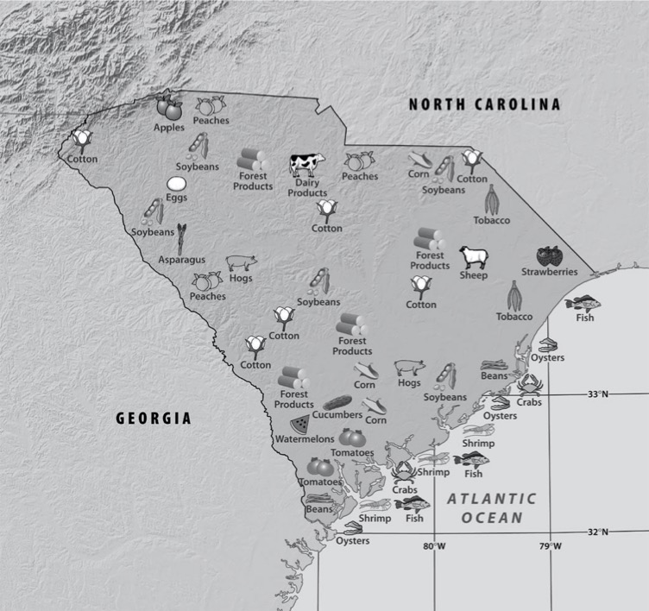

Look at the map and make a list of the various farm products found in South Carolina. Then make a chart and categorize the products as Vegetable, Fruit, Animal, and Other. Finally, write a summary statement based on the data in the chart to explain farming in South Carolina.

Chapter 1: What is Geography?
Answer Section

TRUE/FALSE

1. ANS: T PTS: 1 DIF: Knowledge REF: Chapter 1 Section 2
TOP: Physical Features

2. ANS: F PTS: 1 DIF: Application REF: Chapter 1 Section 2
TOP: Regions

3. ANS: F
The Piedmont Region makes up approximately one-third of the state of South Carolina.

PTS: 1 DIF: Knowledge REF: Chapter 1 Section 2
TOP: Regions

4. ANS: F
Columbia is approximately the geographic center of the state.

PTS: 1 DIF: Knowledge REF: Chapter 1 Section 2
TOP: Physical Features

5. ANS: T PTS: 1 DIF: Knowledge REF: Chapter 1 Section 2
TOP: Climate

MULTIPLE CHOICE

1. ANS: D PTS: 1 DIF: Application REF: Chapter 1 Section 1
TOP: Population

2. ANS: B PTS: 1 DIF: Application REF: Chapter 1 Section 1
TOP: Population

3. ANS: B PTS: 1 DIF: Analysis REF: Chapter 1 Section 1
TOP: Population

4. ANS: D PTS: 1 DIF: Knowledge REF: Chapter 1 Section 3
TOP: Climate

5. ANS: C PTS: 1 DIF: Knowledge REF: Chapter 1 Section 3
TOP: Waterways

COMPLETION

1. ANS: Absolute location

PTS: 1 DIF: Knowledge REF: Chapter 1 Section 1
TOP: Vocabulary

2. ANS: : fauna

PTS: 1 DIF: Knowledge REF: Chapter 1 Section 2
TOP: Vocabulary

3. ANS: : Columbia

PTS: 1 DIF: Knowledge REF: Chapter 1 Section 2
TOP: Regions

MATCHING

1. ANS: F PTS: 1 DIF: Knowledge REF: Chapter 1 Section 1
TOP: Vocabulary

2. ANS: B PTS: 1 DIF: Knowledge REF: Chapter 1 Section 2
TOP: Vocabulary

3. ANS: D PTS: 1 DIF: Knowledge REF: Chapter 1 Section 2
TOP: Vocabulary

4. ANS: E PTS: 1 DIF: Knowledge REF: Chapter 1 Section 2
TOP: Vocabulary

5. ANS: H PTS: 1 DIF: Knowledge REF: Chapter 1 Section 2
TOP: Vocabulary

6. ANS: J PTS: 1 DIF: Knowledge REF: Chapter 1 Section 1
TOP: Vocabulary

7. ANS: G PTS: 1 DIF: Knowledge REF: Chapter 1 Section 3
TOP: Vocabulary

8. ANS: C PTS: 1 DIF: Knowledge REF: Chapter 1 Section 1
TOP: Vocabulary

9. ANS: N PTS: 1 DIF: Knowledge REF: Chapter 1 Section 2
TOP: Vocabulary

10. ANS: L PTS: 1 DIF: Knowledge REF: Chapter 1 Section 2
TOP: Vocabulary

11. ANS: O PTS: 1 DIF: Knowledge REF: Chapter 1 Section 3
TOP: Vocabulary

ESSAY

1. ANS:
Vegetable | Fruit | Animal | Other
soybeans  asparagus  cucumbers  corn  beans | apples  peaches  strawberries  watermelons  tomatoes | dairy cows  sheep  hogs | cotton  tobacco

Answers will vary but might say: South Carolina produces more fruits and vegetables than animal products.

PTS: 1 DIF: Comprehension REF: Chapter 1 Section 1
TOP: The Economy

